Psql vs plpgsql

Scripts: prepare.sql, test_sql.sql, test_plpgsql.sql

test_sql.sql  
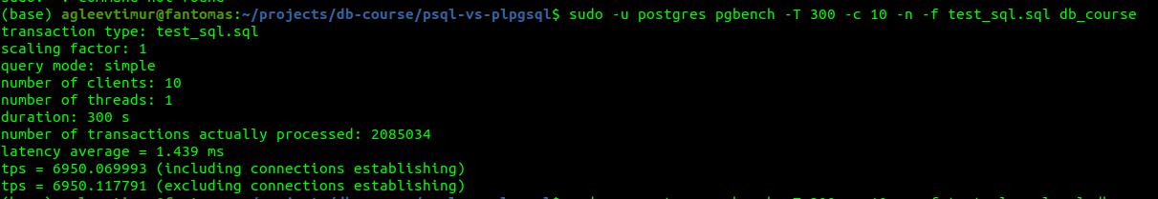  
tps = 6950.117791

test_plpgsql.sql  
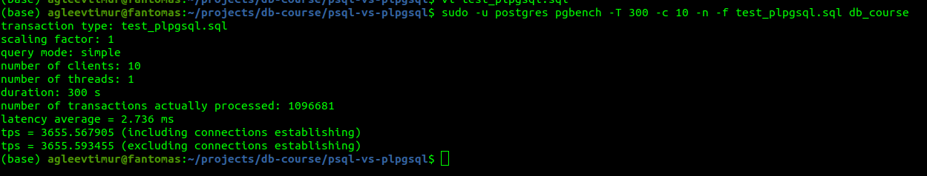

tps = 3655.593455